USER DOCUMENTATION

Author Nick Sherstiuk

Project Library - my first project written in Java EE at the JSP level.

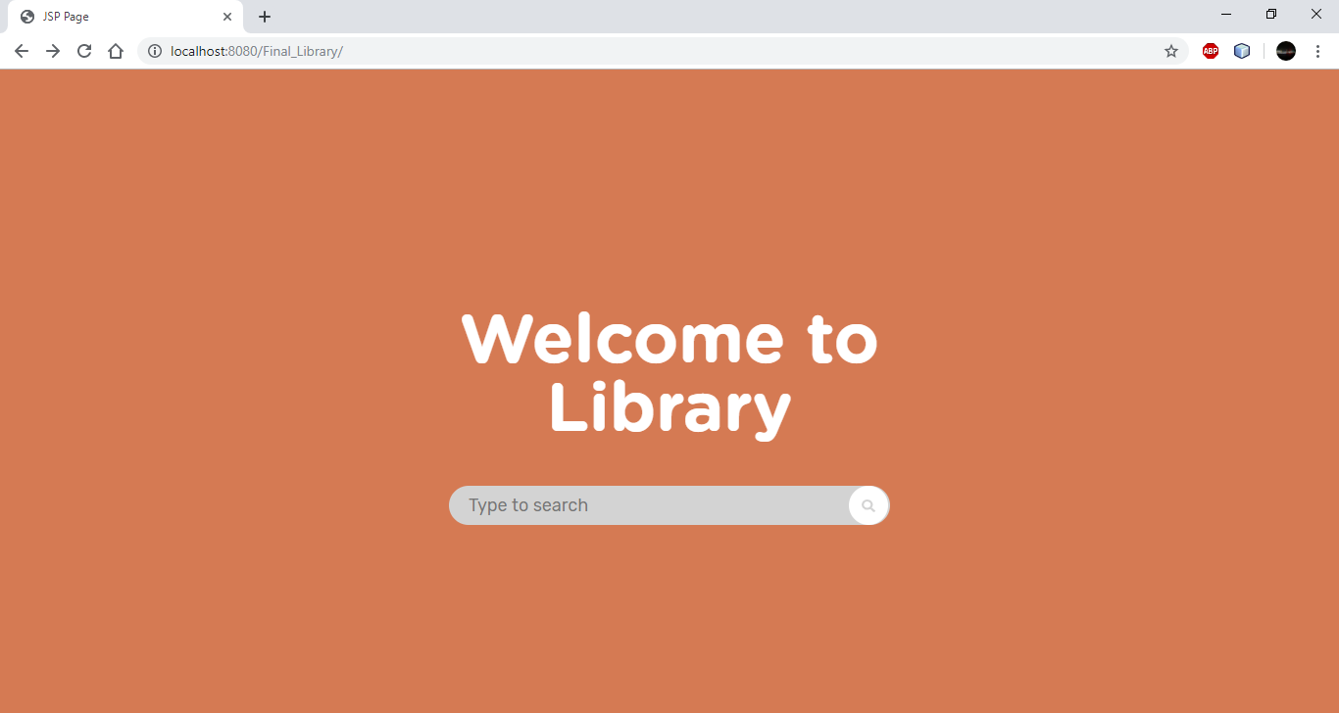

You can search for books by using the search bar. Books with Russian names, because I was looking for information in this place-the site. Therefore, UTF-8 is used. This is a list of books:

451 градус по Фарингейту

Алые паруса

Бегущая по волнам

Властелин колец

Лед и пламя

Над пропастью во ржи

Сердца трех

Сильмариллион

Смок Беллью

Эркюль Пуаро

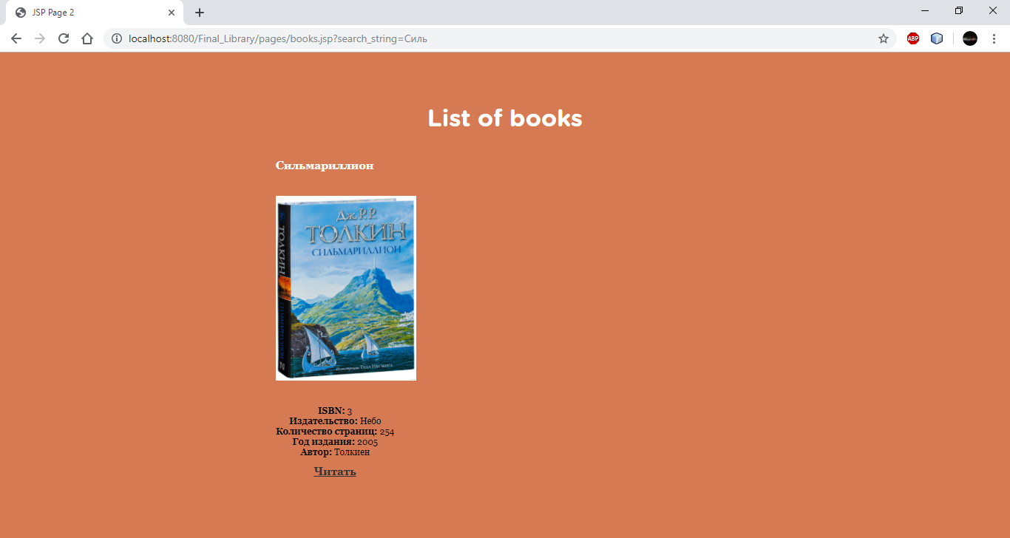

In addition, this project can create features such as all books breaking down into literary genres and Letters, but create the front end is needed.

